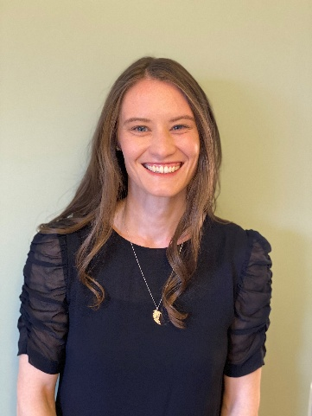
Cecilia White, J.D.
Emissions Credit Trading Supervisor
CDPHE Air Pollution Control Division

Cecilia serves as the Emissions Credit Trading Unit Supervisor within the Climate Change Program at the Colorado Department of Public Health and Environment (CDPHE). She is a licensed attorney in Colorado. Although not currently practicing, her professional experience expands environmental sustainability and climate policy with governments, nonprofits, and large corporations. Before joining CDPHE, Cecilia was the Sustainability Analyst for Republic Services based out of Phoenix, Arizona and a climate change mitigation consultant with ICF based out of Washington D.C. Whenever she has a moment, Cecilia loves to travel and be outside in nature skiing, playing ultimate frisbee, rock climbing, and hiking.

